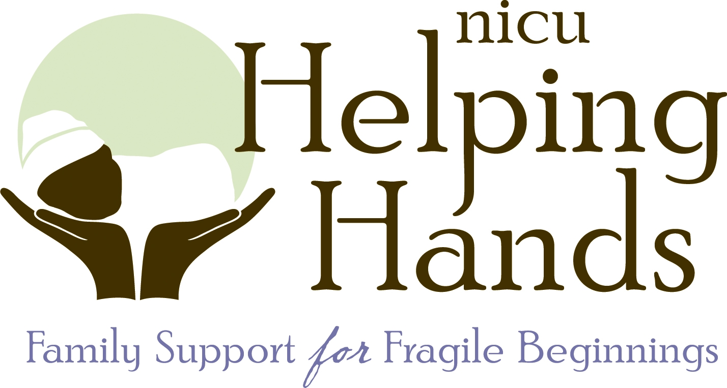

Dear One-on-One Mentor Applicant:

Thank you for your interest in the NICU Helping Hands’ One-on-One Mentor Program. This mentoring program is only possible because of parents like you who are willing to selflessly give back and help others. You have a unique perspective that is incredibly helpful for families to hear and experience. There is no doubt that you are making a significant difference in a family’s life through this program.

The One-on-One Mentoring Program is a specialized program that provides antepartum, NICU, post-NICU and bereaved families with a mentor to provide support and guide them through their journey. The goal is not to have you “fix” problems, but rather to be someone for them to talk to and encourage them when the tough times come their way.

To be eligible to volunteer you must first fill out the volunteer application. Once you have completed it please mail, fax, or email your application back to NICU Helping Hands. Once we receive your application, you will be sent information regarding our next mentor training session and to set-up a personal interview with one of our team members. Our next training session for mentors will be held Saturday, November 12, 2016 from 10-1pm at Baylor All Saints Medical Center.

Thank you for your interest in NICU Helping Hands. If you have any questions, please do not hesitate to contact us.

Warmly,

Lisa Grubbs, President
NICU Helping Hands
3023 S. University Drive, Suite 211
Fort Worth, Texas 76109
817-668-5191
lgrubbs@nicuhelpinghands.org
www.nicuhelpinghands.org

One-on-One Mentor Program Application
Please print clearly and fill out the application completely

Name (first, middle and last): __________________________________________________________________________
Home Address:_________________________________________________________________ Apt/Suite: ___________
City: _______________________________________________ State: ___________________ Zip: _______________
Phone Numbers: ________________________ ________________________ ___________________
Please Include area codes Cell Home Work
Preferred Method of Communication: Cell Home Work Best Time to Call: __________________
Male ( ) Female ( ) Email: _________________________________________________________________________
Date of Birth: ________________
Employer: ____________________________________________________ Position: _________________________
Work Address:______________________________________________________________________________________
City: _______________________________________________ State: ___________________ Zip: _______________

Why are you interested in serving as a One-on-One Mentor?
_____________________________________________________________________________________________________________________________________________________________________________________________________________________________________________________________________________________________________________________________________________________________________________________________________________________________________________________________________________________________________________________________________________________________________________________________________________________________________________________________________________________________________________________________________________________________________________________________________________________________________________________________________________________________________________________________________________________________________________________________________________________________________________________________________________________________________________________________________________________________________________________________________________________________________________________________________________________________________________________________________________________________
NHH Use Only
Received: _______________ Contacted: ____________ Orientation: _______________ Background Check: _______

How did you hear about the NHH One-on-One Mentoring Program?
( ) Word of Mouth ( ) NICU Stay ( ) NHH Event ( ) Website/Social Media ( ) Other ____________________________
Please list any languages that you speak, read and/or write fluently, in addition to English: ________________________
Children at home:
Name: _________________________________________ Age: ______________________ NICU Stay: ( ) Yes ( ) No
NICU Info (Gestational Age, Weight, etc) if applicable: ______________________________________________________

Name: _________________________________________ Age: ______________________ NICU Stay: ( ) Yes ( ) No
NICU Info (Gestational Age, Weight, etc) if applicable: ______________________________________________________

Name: _________________________________________ Age: ______________________ NICU Stay: ( ) Yes ( ) No
NICU Info (Gestational Age, Weight, etc) if applicable: ______________________________________________________

Name: _________________________________________ Age: ______________________ NICU Stay: ( ) Yes ( ) No
NICU Info (Gestational Age, Weight, etc) if applicable: ______________________________________________________

Other Children at home: ______________________________________________________________________________

We need peer mentors for parents who are experiencing an antepartum stay, a NICU hospitalization or the loss of a baby. If you have experienced any of these things we need YOU. We require that a mentor be post-experience a minimum of two years before serving as a NICU Helping Hands’ One-on-One Mentor. Please answer the following questions as they pertain to your experience.

1. How long has it been since your antepartum stay, NICU discharge or loss of your baby? ______________________________________________________________________________________________________________________________________________________________________________________

2. Please describe your experience.
_____________________________________________________________________________________________________________________________________________________________________________________________________________________________________________________________________________________________________________________________________________________________________________________________________________________________________________________________________________________________________________________________________________________________________________________________________________________________________________________________________________________________________________________________________________________________________________________________

3. Did you participate in any type of parent support program either while in the hospital or after discharge? If so, please describe the experiences that you had.
(Ex. online support groups, hospital support groups, church/community organizations, blogs, sibling support)
_________________________________________________________________________________________________________________________________________________________________________________________________________________________________________________________________________________________________________________________________________________________________________________________________________________________________________

4. What is one piece of advice that you would give to a current family on how to handle the stress that they are experiencing?
______________________________________________________________________________________________________________________________________________________________________________________________________________________________________________________________________________________________________________________________________________________________________________________________________________________________________________________________________________________________________________________________

Have you volunteered for any other organizations? ( ) Yes ( ) No (if you checked yes, please continue below)
Organization Name: _________________________________________ Starting Date: ________ End Date: ___________
Describe volunteer service below:
__________________________________________________________________________________________________________________________________________________________________________

Organization Name: _________________________________________ Starting Date: ________ End Date: ___________
Describe volunteer service below:
__________________________________________________________________________________________________________________________________________________________________________

Do you have any hobbies or special talents?
_______________________________________________________________________________________________________________________________________________________________________________________________________________________________________________________________

There can be challenging emotional demands from working with families going through a difficult pregnancy, NICU stay or loss of a baby. Is there anything that NHH needs to be made aware of to ensure that your experience is a pleasant one?
_______________________________________________________________________________________________________________________________________________________________________________________________________________________________________________________________

Please list 3 references: (no family members please)

________________________ _____________________ ______________ ___________________________
Name Relationship Time Known Phone Number

________________________ _____________________ ______________ ___________________________
Name Relationship Time Known Phone Number

________________________ _____________________ ______________ ___________________________
Name Relationship Time Known Phone Number

Have you ever been charged with or convicted of the following: (please check yes or no)
- Felony? ___ Yes ___ No
- Any crime involving a sexual offense, an assault or the use of a weapon? ___ Yes ___ No
- Any crime involving the use, possession or the furnishing of drugs, prescription drugs, or hypodermic syringes? ___ Yes ___ No
- Reckless driving, operating a motor vehicle while under the influence, or driving to endanger? ___ Yes ___ No
If you answered Yes to any of the above items, please explain: ___________________________________________________________________________________________________________________________________________________________________________________________________________________________________________________
NICU Helping Hands has my permission to:
Please check below

Run a background check on me: ___ Yes ___ No
Verify the 3 references that I have provided: ___ Yes ___ No
By signing below, I affirm that I have answered all questions truthfully. I understand that if any portion of this application is found to be intentionally false, I may be denied the right to volunteer with NICU Helping Hands.

_______________________________________________________________ __________________________
Signature Date

Release for Publication
Please initial below

During the course of serving with NICU Helping Hands, there will be occasions when you may be photographed and/or videotaped by staff, sponsors, corporate representatives, media or others. We request permission for your participation. By initialing below, you may choose to grant or deny NICU Helping Hands permission to use photographs or videotapes of yourself, alone or in groups, in (but not limited to) newspaper articles, newsletters, website, social media, online, brochures, special fundraising activities, scrapbook, videos and photo albums for use in public understanding and support of the NICU Helping Hands program. By granting permission below, you hereby release and hold harmless NICU Helping Hands from any claims, judgments, or demands that may arise from the use of the above referenced photographs and/or video.

_____ (Initial) “YES, I give permission to be photographed and/or videotaped for publication”

OR

_____ (Initial) “NO, I deny consent to be photographed and/or videotaped for publication”

